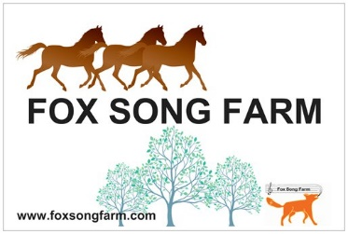
Fox Song Farm Safety Covenant and Release
Kindle Health at Fox Song Farm
26917 – 20th Avenue Aldergrove, BC V4W 2P2

Dr. Faith Richardson, DNP RN

Fox Song Farm ‘Let’s all be Safe’ Rules
- No treats! Please don’t handfeed the horses. Yes, Faith does it, but horses are smart and know who does and who doesn’t. We don’t want you or other guests to be ‘mugged’ or have your pockets searched.
- Don’t open gates that are closed and don’t close gates that are open.
- Do not enter an area where horses are being held unless invited to do so by Faith or another FSF person.
- Don’t bring your dog or any other animal to FSF. We know you love your dog, and that he/she is the smartest, best behaved dog in the entire world and that he/she would NEVER chase another animal or hunt a chicken. Doesn’t matter. No visiting dogs.
- No smoking anywhere on the property.
- We recommend that you wash your hands or use hand sanitizer after playing with the goats. Goats can carry a self-limiting virus that is similar to a chicken-pox rash. We’ve never had an outbreak, but want to ensure you are aware of the possibility and safe!
- Don’t go into living spaces (house, RV trailers). They are not affiliated with FSF-KH.
- Be responsible for yourself. If you are uncomfortable with anything, say so and say ‘no’. We promise to listen, explain our thinking, adjust things, change course.
- The safest place to be when around animals (or people, for that matter!) is to be grounded, centered, ‘in your body.’ So … breathe, wiggle your toes and feel the ground under your feet, smell the fresh air, hear the birds, and stretch your hands and touch your fingertips together. Acknowledge to yourself current feelings/thoughts and simply let them be … like drops of rain or the sunlight around you. Be here, now.
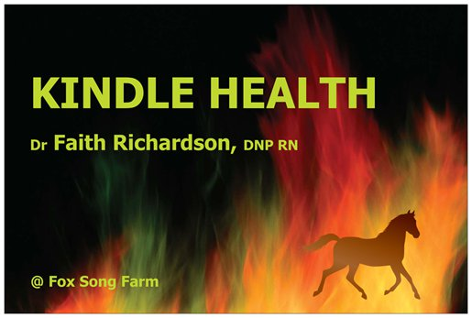
Adult Participant Release of Liability Agreement
(one copy for us; one copy for you)
Kindle Health at Fox Song Farm
26917 – 20th Avenue Aldergrove, BC V4W 2P2

Dr. Faith Richardson, DNP RN

I, (participant)

for and in consideration of the agreement of Kindle Health at Fox Song Farm (KH-FSF) to provide Animal Assisted Activities/Animal Assisted Therapy to myself, do hereby forever release, acquit, discharge and hold harmless KH-FSF, its officers, trustees, agents, employees, representatives, successors and assigns, for all manner of claims, demands, and damages of every kind and nature whatsoever, which the undersigned may now, or in the future, have against KH-FSF, its officers trustees, agents, employees, representatives, successors or assigns on account of any personal injuries, physical or mental condition, known or unknown, to the undersigned and the treatment therefor as a result of, or in any way growing out of, the acts of KH-FSF, its officers, trustees, agents, employees, representatives, successors or assigns, including but not limited to, their negligence or gross negligence, in rendering the services above described or in any way incidental thereto.

Your signature: Date:

Adult Participant Release of Liability Agreement
Kindle Health at Fox Song Farm
26917 – 20th Avenue Aldergrove, BC V4W 2P2

Dr. Faith Richardson, DNP RN

I, (participant)

for and in consideration of the agreement of Kindle Health at Fox Song Farm (KH-FSF) to provide Animal Assisted Activities/Animal Assisted Therapy to myself, do hereby forever release, acquit, discharge and hold harmless KH-FSF, its officers, trustees, agents, employees, representatives, successors and assigns, for all manner of claims, demands, and damages of every kind and nature whatsoever, which the undersigned may now, or in the future, have against KH-FSF, its officers trustees, agents, employees, representatives, successors or assigns on account of any personal injuries, physical or mental condition, known or unknown, to the undersigned and the treatment therefor as a result of, or in any way growing out of, the acts of KH-FSF, its officers, trustees, agents, employees, representatives, successors or assigns, including but not limited to, their negligence or gross negligence, in rendering the services above described or in any way incidental thereto.

Your signature: Date:

